

Year 8 Science 2020
Biology 1 Test: Cells

SECTION 1: MULTIPLE CHOICE (1 mark each)
Circle your answer on the multiple choice answer sheet.

The first two questions are about the following diagram, which shows onion cells under a microscope.

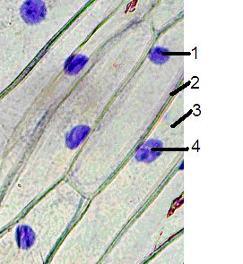

- What is the name of the structure that is labelled 1 on the diagram above?
  - nucleus
  - membrane
  - golgi
  - mitochondria

- The cytoplasm is labelled
  - 1
  - 2
  - 3
  - 4

- Which of the following is found in an animal cell?
  - cell membrane
  - cell wall
  - chloroplasts
  - large vacuoles

- Which part of a cell controls cell functions and contains DNA, the “recipe” for all cell parts and products?
  - cell membrane
  - nucleus
  - cytoplasm
  - vacuole

- The function of chloroplasts is
  - making food by the process of photosynthesis.
  - producing energy by the process of respiration.
  - protecting the cell from damage by chemicals or germs.
  - making the cell turn green.

- The function of the cell wall and vacuoles is
  - the cell wall stores water that keeps the cell rigid, while the vacuole drains this water away.
  - the vacuole fills up with water, pushing the cell contents against its wall, keeping it rigid.
  - the cell wall shrinks to pump water into the vacuole.
  - the cell wall is thin and weak, but the vacuole is tough and rigid..

- Which of the following is not a process that animal cells undergo?
  - respiration
  - diffusion
  - division
  - photosynthesis

- How do we grow?
  - Our cells get bigger.
  - We get less cells.
  - Cells divide in two to make new cells.
  - Each cell produces lots of smaller cells, which slowly get bigger.

- Our cells’ energy source is
  - glucose.
  - sucrose.
  - oxygen.
  - sunlight.

- Plants can photosynthesise without
  - sunlight.
  - oxygen.
  - carbon dioxide.
  - water.


SEMESTER ONE 2020
Biology Science Test Year 8:
ANSWER BOOKLET

NAME:
FORM: DATE:

Multiple Choice Short Answer Total

/10

/30

/20

SECTION ONE: Multiple choice answers
Cross (X) through the correct answer.

1 | a | b | c | d
2 | a | b | c | d
3 | a | b | c | d
4 | a | b | c | d
5 | a | b | c | d
6 | a | b | c | d
7 | a | b | c | d
8 | a | b | c | d
9 | a | b | c | d
10 | a | b | c | d

SECTION 2: WRITTEN
Write your answers on the lined paper provided. Total 20 marks

- Write the name of the cell parts labelled A to F on the diagrams below (6)

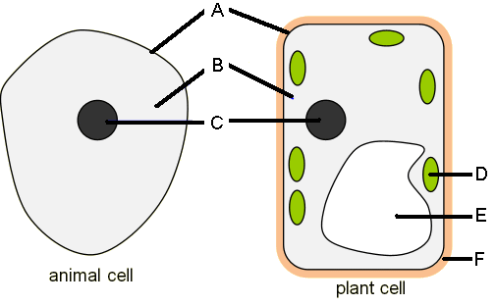
A _______________________ B ______________________

C _______________________ D ______________________

E _______________________ F ______________________

- Write the word equation for respiration (1)

_______________________________________________________________

- Write the word equation for photosynthesis (1)

_______________________________________________________________

- Name the cell part that carries out each function (5)
- The outer boundary of the cell, lets some things into and out of the cell

_______________________________

- The tough, rigid structure that surrounds a plant cell

________________________________

- Makes energy for the cell by respiration

________________________________

- Where proteins are made

_______________________________

- A collection of membranes that transport materials around the inside of the cell

_______________________________
- Complete the table below by writing the number that matches each part name. (7)

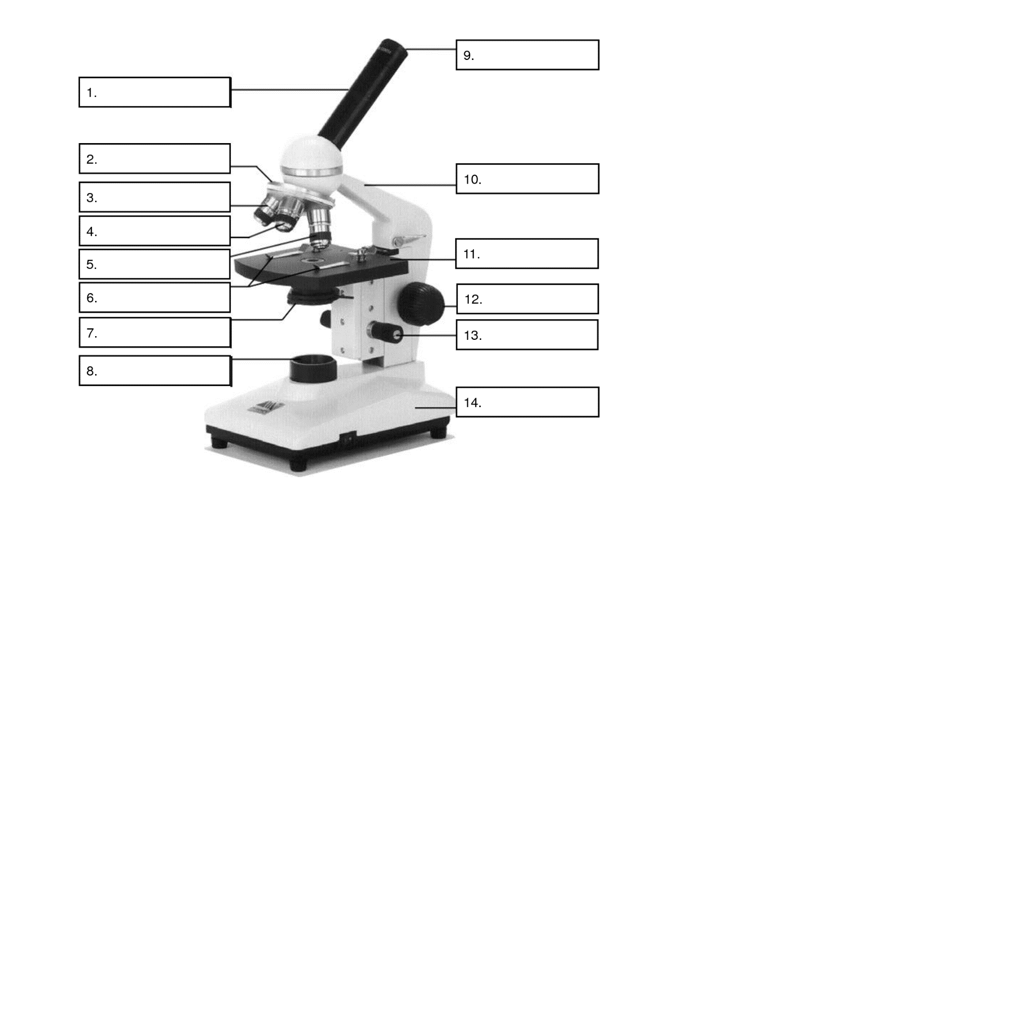

Letter | Part Name | Number
A | Light
B | Stage Clips
C | Eye Piece
D | Body Tube
E | Arm
F | Coarse Focus
G | Nose Piece
H | Iris diaphragm
I | Lower Power
J | Stage
K | Fine Focus
L | High Power
M | Base
N | Medium Power

